# Resource Discovery

The concept is associated to the possibility for a consumer/client application (through a specific Application Protocol) to find the list of available resource hosted and managed by an IoT smart object.

The purpose is to simplify and automate the seamless interaction and interoperability among object without prior knowledge.

CoAP support Resource Discovery

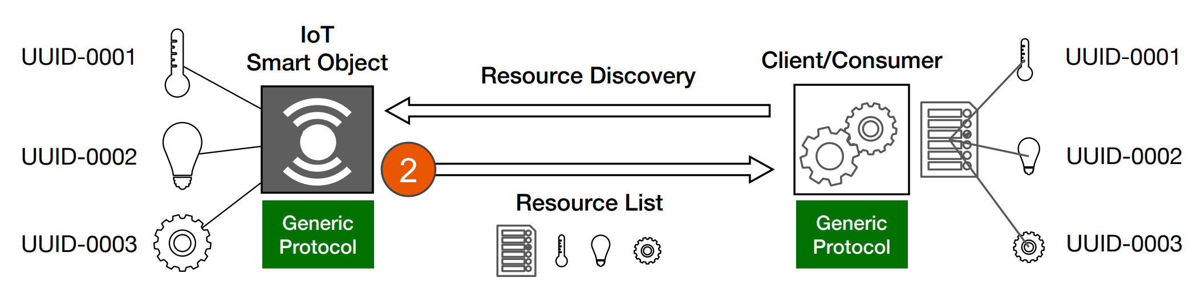

To obtain the Resource list is necessary to send a GET request to **/.well-known/core**

The list will be in **CoRE Link Format**

Constrained Restful Environments **CoRE** implements the REST architecture.

The main function is to provide URIs called links

The resource are complemented by attributes about those resource and possible further link relations

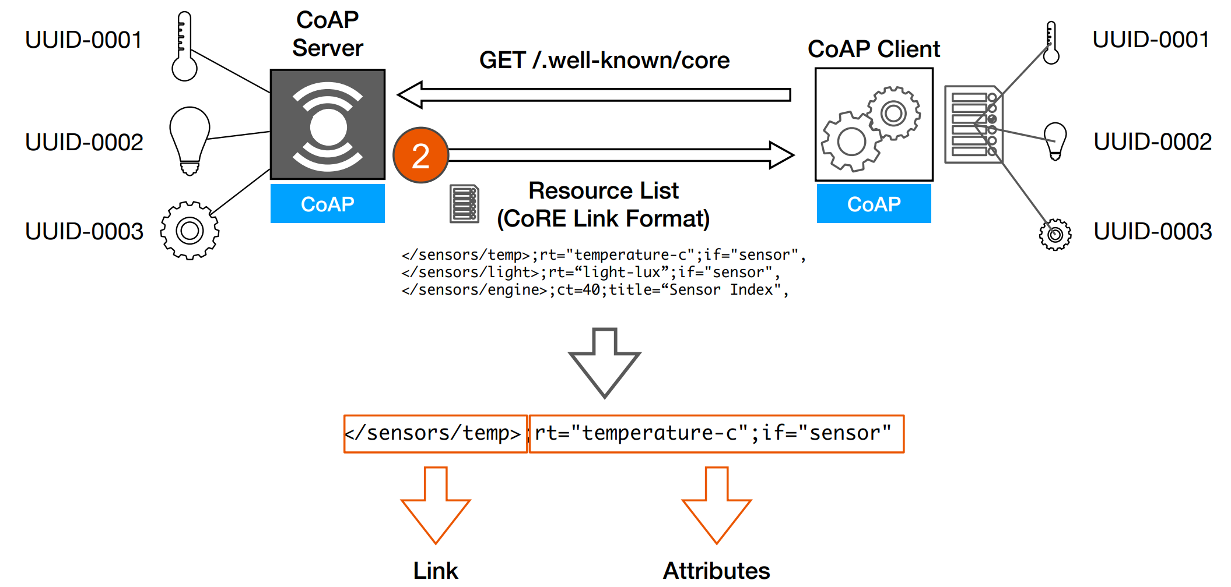

**Resource Type ‘rt’**

Is an opaque string used to assign an application-specific semantic type to a resource

**Interface description ‘if’**

Provide a name or a URI, could be reused.

**Maximum Size ‘sz’**

Maximum size of the resource representation by performing a GET

**Observability ‘obs’**

It’s a hint indicating that the destination of a link is useful for observation

**Query filtering**

/.well-known/core{?search*}

* ?href=/foo 🡪 matches a link-value equals to /foo
* ?href=/foo* 🡪 matches a link-value that starts with /foo
* ?foo=bar 🡪 matches a link-value that has a target attribute named foo with the exact value bar
* ?foo*=bar 🡪 matches a link-value that has a target attribute named foo, the value which start with bar
* ?foo=* matches a ink-value that has a target attribute named foo

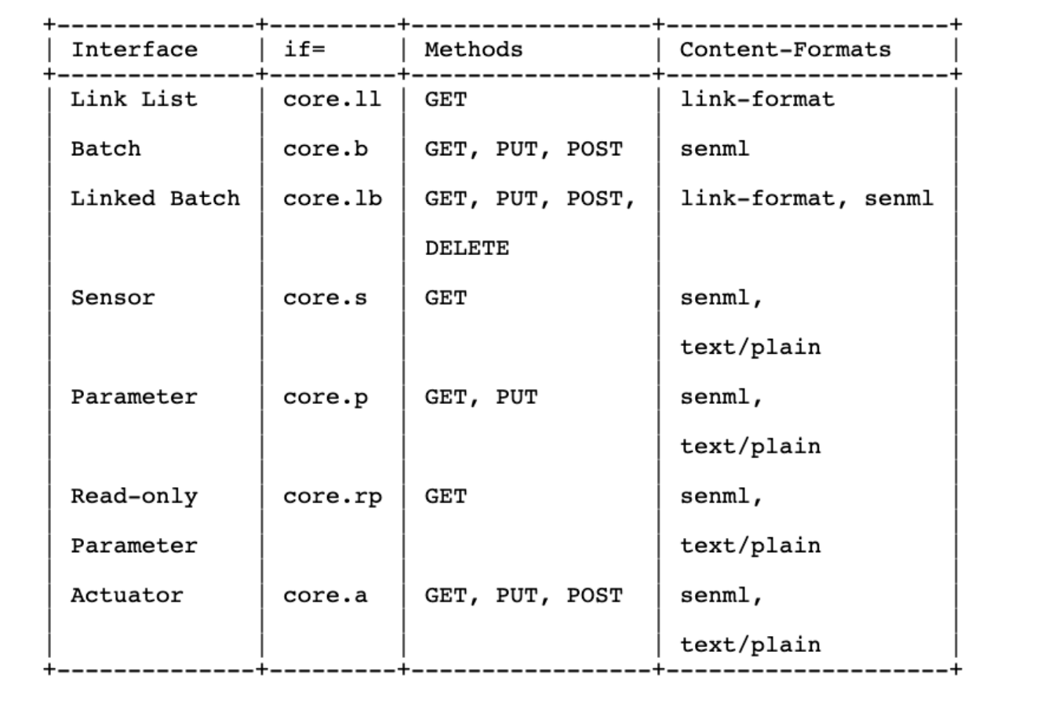

**SenML 🡪 Sensor Measurement Lists**

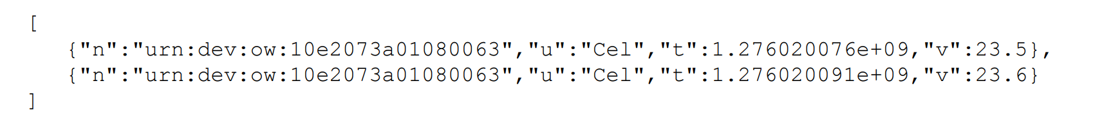

Base name concept to reduce the length of the message, the following message will be from the same device

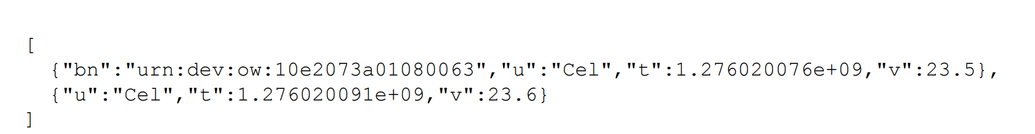

● SenML **Record**: One measurement or configuration instance in time presented using the SenML data model

● SenML **Pack**: One or more SenML Records in an array structure

● SenML **Label**: A short name used in SenML Records to denote different SenML fields (e.g., "v" for "value")

● SenML **Field**: A component of a record that associates a value to a SenML Label for this record

● SenSML: **Sensor** Streaming Measurement List

● SenSML **Stream**: One or more SenML Records to be processed as a stream

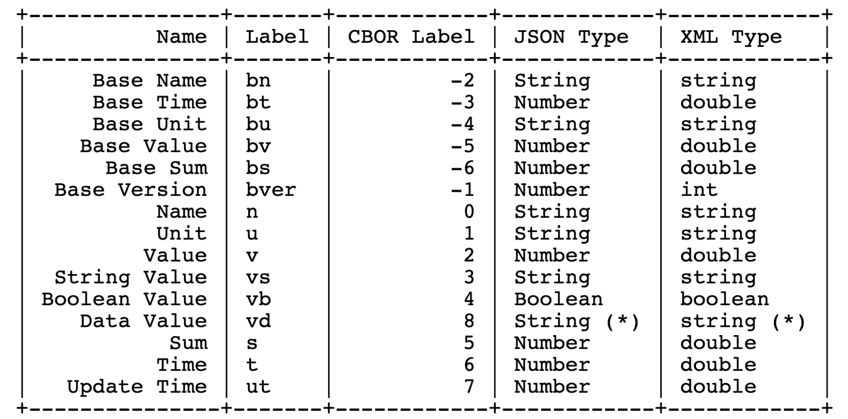

**Definitions:**

● Base Name: This is a string that is prepended to the names found in the entries.

● Base Time: A base time that is added to the time found in an entry.

● Base Unit: A base unit that is assumed for all entries, unless otherwise indicated. If a record does not contain a Unit value, then the Base Unit is used. Otherwise, the value found in the Unit (if any) is used.

● Base Value: A base value is added to the value found in an entry, similar to Base Time.

● Base Sum: A base sum is added to the sum found in an entry, similar to Base Time.

● Base Version: Version number of the media type format. This field is an optional positive integer and defaults to 10 if not present.

A Resource Directory is used as a repository of registrations describing resources hosted on other web servers (Endpoints)

Finding a Rd is possible doing a GET /.well-known/core?=rt=core.rd*

Take a look to Zero Conf at the end od 12 power point,